1. Download QGIS here: <http://www.qgis.org/en/site/>
2. Clone the OpenSMC github repository: <https://github.com/opensmc/ssmc-agriculture-zoning>
3. Download the following shapefiles from the County GIS download site:
   1. San Mateo County Active Parcels <http://maps.smcgov.org/gis_data_download/SAN_MATEO_COUNTY_PARCELS.zip>
   2. San Mateo County Streets <http://maps.smcgov.org/GIS_data_download/SAN_MATEO_COUNTY_STREETS.zip>
   3. Jurisdictional Boundaries <http://maps.smcgov.org/GIS_data_download/JURISDICTIONAL_BOUNDARIES.zip>
4. Open QGIS and add the San Mateo County parcel, streets, and boundaries shapefile (.shp) by clicking on the **Add Vector Layer** button.



1. Zoom to the city or town of interest you’re working on using the navigation tools along the top window.



1. Pull up an authoritative map of the city zoning, which can be sourced from the Google spreadsheet here: <https://docs.google.com/spreadsheets/d/199shxJaRycwVGXGR46jQNyur960dnPf-L7-lIcXyKRg>
2. In QGIS, select some parcels from a single zoning designation using the **Select by Polygon** tool 

Start drawing a polygon that intersects the parcels you would like to select. To complete the selection polygon you’ll need to right-click to close it.

1. Open the attribute table of the dataset by right-clicking on the file in the Layers Panel window and selecting **Open Attribute Table**



1. Begin an edit session by clicking on the pencil icon.
2. To specify zoning attributes of these parcels, click on the **Open field calculator** tool, which looks like an abacus (keyboard shortcut = Ctrl + I ). Choose to **only update the selected features** (NOTE that if you don’t have this checked it will overwrite attribute values for all parcels). Choose to update an existing field and specify the **Zoning** column. In the **Expression** window specify the zoning designation using quotes around the text.

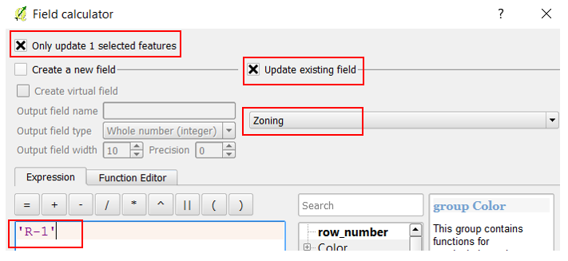

1. So it is easier to keep track of what parcels you have edited going forward, try changing the way data are displayed. Right click on the file and select the **Properties** tab. Click on the **Style** tab. Select *Categorized* as the type, *Zoning* as the column. Then click the **Classify** button.

